BIOGRAPHY DR. SUSAN D’ALOIA
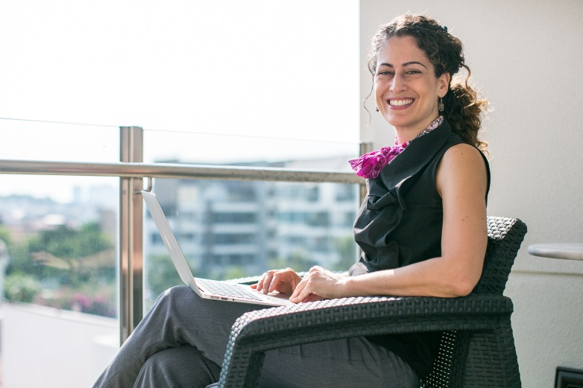
Dr. Susan D’Aloia is the Client Success Advocate for Blackboard, serving the Asia Pacific region. As an interdisciplinary educator and program developer, Susan has worked as a consultant and trainer in the United States, Latin America and Asia. She has worked with public and private schools, non-traditional learning institutions as well as colleges and universities.
Susan has served as a Director, Department Head, an Associate Director and an Advisor and has taught over 1,000 hours of fully online and blended learning instruction. In addition to her doctoral degree, Susan earned a graduate degree in fine arts from Sarah Lawrence College and has a graduate level certificate in education. Her essays and scholarship have been published in journals including the Global City Review, New Renaissance Magazine, Internarrative Identity Revisited from Palgrave Macmillan and in The Future of English in Asia by Routeledge Press. Most recently her work has been published in 21st Century Holistic Learning and ELearn Magazine.
Her current workshop focus includes how to make Universal Design Principles of Learning come alive and interdisciplinary approaches to Outcomes Based Education. She also serves as a lead trainer of Blackboard’s eTeacher Certification program.

